Drawing with the Library of Functions
By ( )
Student’s Name
Professor’s Name
Course
Date

Drawing with the Library of Functions.
Definitions for more understandings
 | Vertical | Horizontal
Scale | a | b
Shift | d | c
 | Acts normally | Acts inversely

Constant Function: y = c
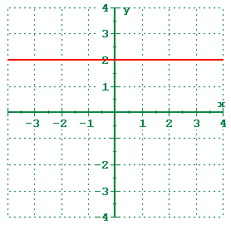
Linear Function: y = x
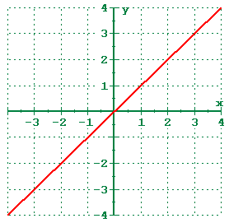
Quadratic Function: y = x²
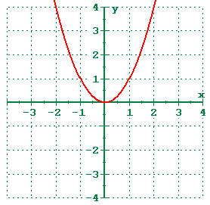
Cubic Function: y = x³
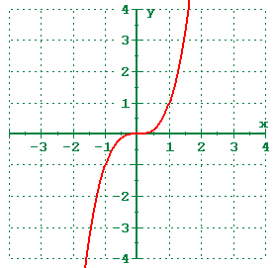
Absolute Value Function: y = |x|
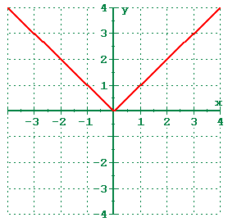
Square Root Function: y = sqrt(x)
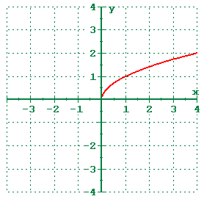

Solutions

- $f\left(x\right)=x \{0<x<2\}$
Solution

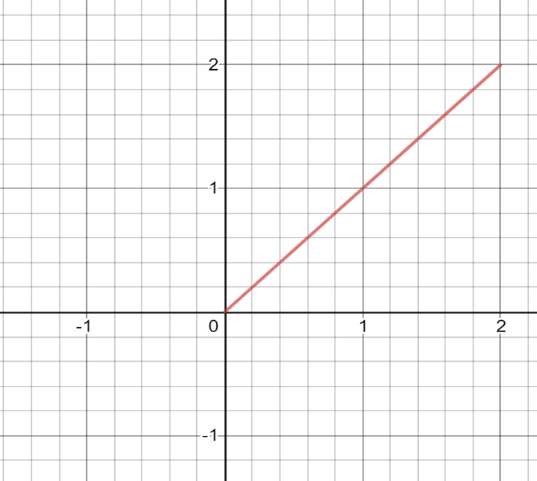
This is the original graph generated by the equation above.

Transformations
Having equation
y=af (b (x-c)) +d
Y = y coordinate
a = slope
X = x coordinate
d = y intercept
Domain of x, ( 0 < x <2)
(0,2)
Range of x, (0 <f(x)< 2 )
(0,2)
X - Axis interception points of x, 0 < x <2 ; None
y - Axis interception points of x, 0 < x <2 ; None

Taking a= -1, b= 0.5, c= 0 and d=0
We get

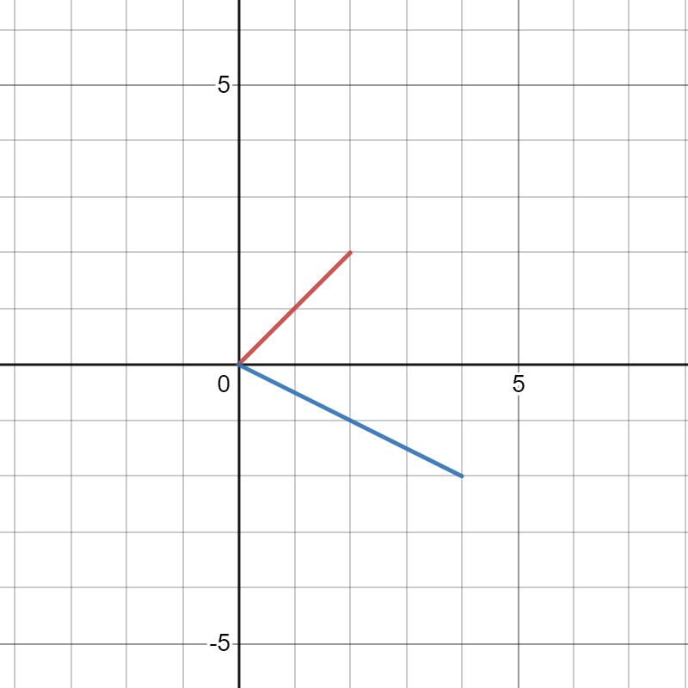

The new graph is reflected on the opposite side where (A = -1) then having (b =0.5) the image is stretched twice and having (c = 0 and d = 0). The line starts and ends the same point.
On the same image letting
x=f(y)
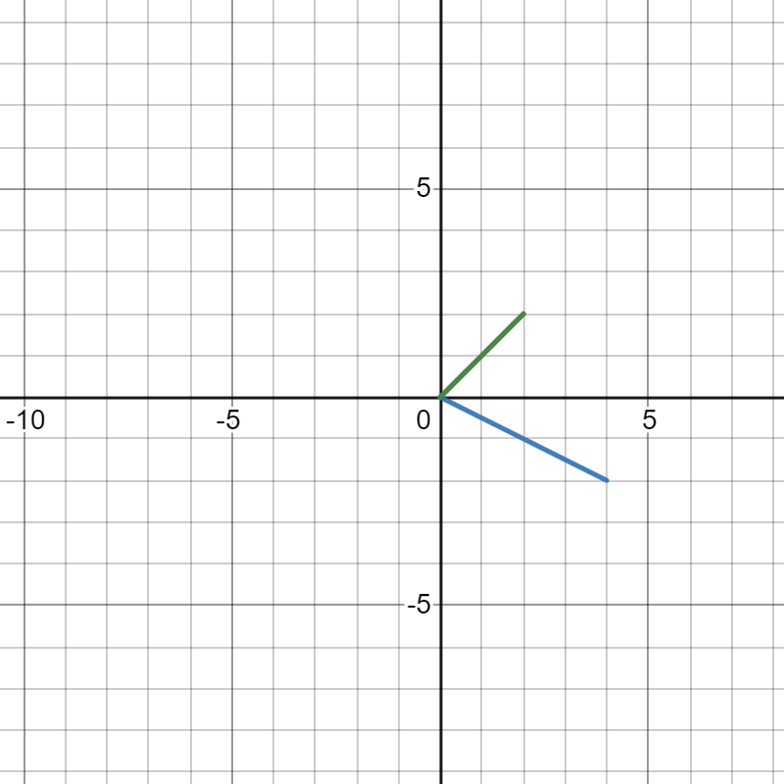

The graph image will be on the same position with the original one. Having no transformations.

- f(x)=x^{2}{0<x<2}
Solution

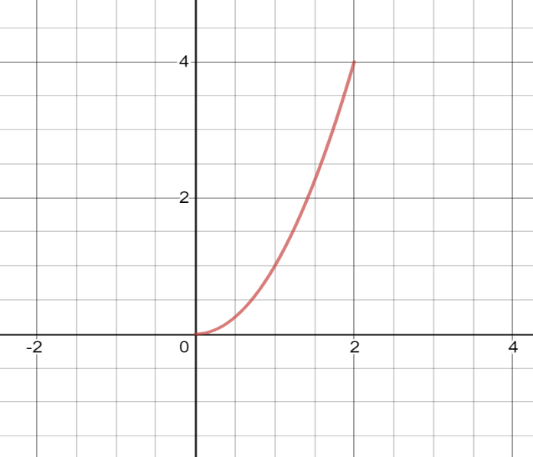
This is the original graph generated by the equation above.

Transformations

Having equation
y=af (b (x-c)) +d
Taking
a=-1
b=1
c=0
d=0
x=f(y)
Domain of x², ( 0 < x <2)
(0,2)
Range of x², (0 <f(x)< 4 )
(0,4)
X - Axis interception points of x² , 0 < x <2 ; None
y - Axis interception points of x² , 0 < x <2 ; None

We get

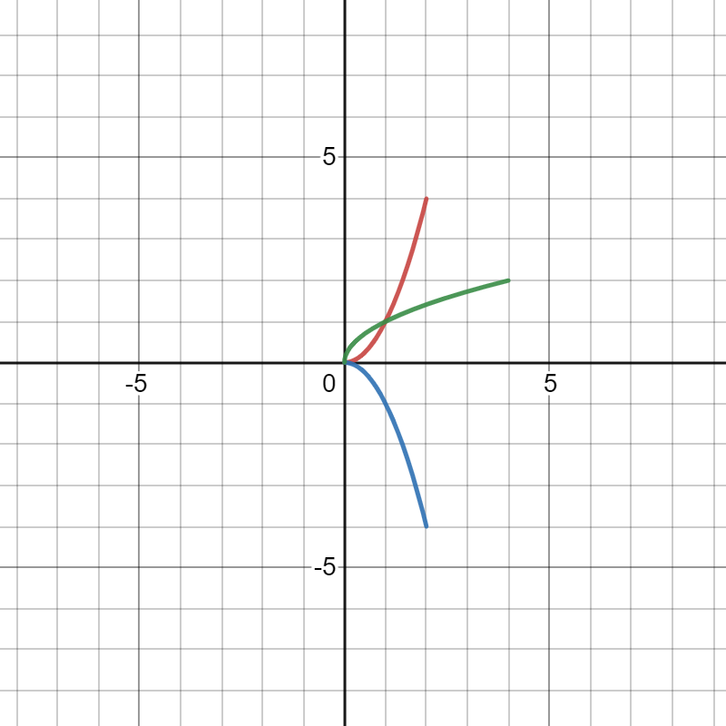
The green graph image is the transformation when x=f(y).it is the same stretched the same distance as the original image but it is generated on the opposite direction.
Having the (A = -1 and B = 1) the graph image is reflected on the opposite direction having the same but opposite co-ordinates. Having (c= 0 and d =0) the image starts the same point as the original one.

- f(x)=x^{3}{0<x<2}

Solution

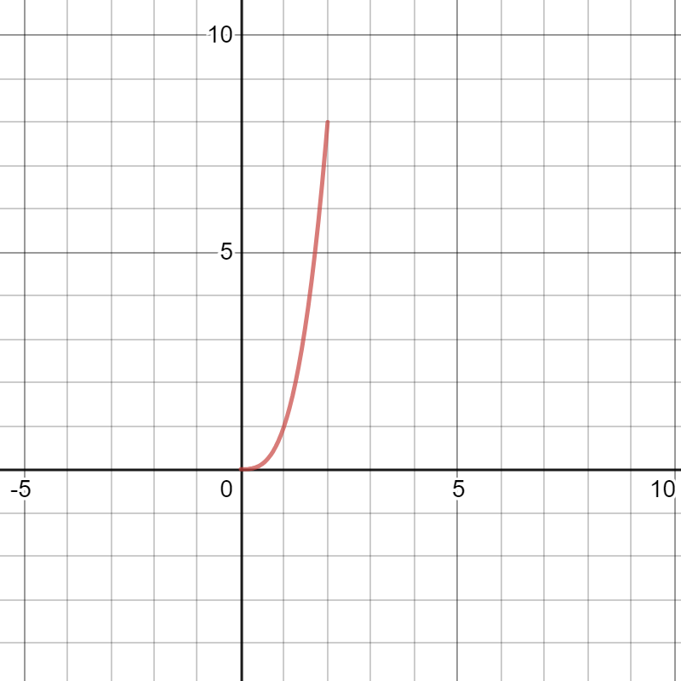
This is the original graph generated by the equation above.

Transformations
Having
y=af (b (x-c)) +d
a=-1
b=1
c=0
d=0
x=f(y)
Domain of x³, ( 0 < x <2)
(0,2)
Range of x³, (0 <f(x)< 8 )
(0,8)
X - Axis interception points of x³ , 0 < x <2 ; None
y - Axis interception points of x³ , 0 < x <2 ; None

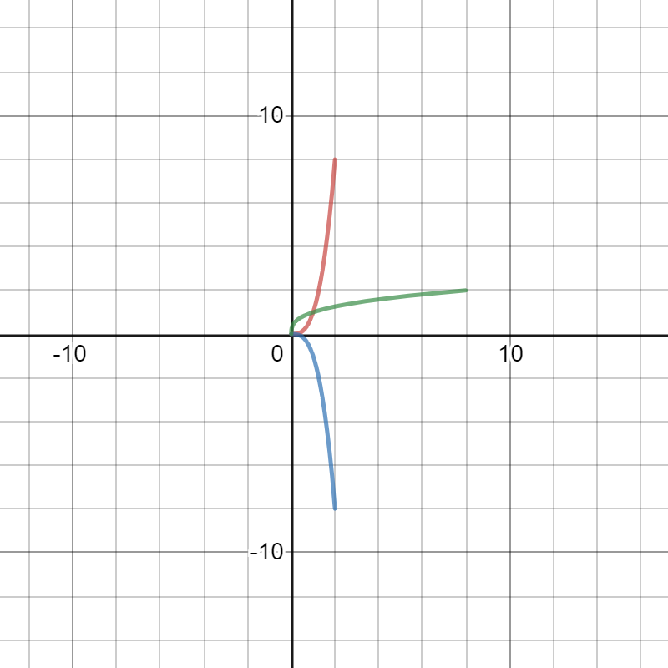
The green graph image is the transformation when x=f(y).it is the same stretched the same distance as the original image but it is generated on the opposite direction.
Having the (A = -1 and B = 1) the graph image is reflected on the opposite direction having the same but opposite co-ordinates. Having (c= 0 and d =0) the image starts the same point as the original one.

- f(x)=sqrt{x} {0<x<2}
Solution

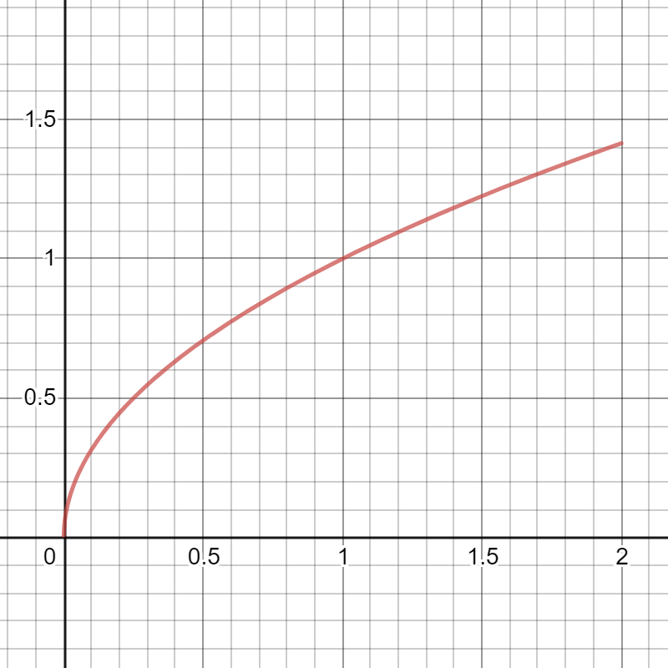
This is the original graph generated by the equation above.

Transformations
Having
y=af (b (x-c)) +d
a=-1
b=0.5
c=0
d=0
Domain of sqrt x, ( 0 < x <2)
(0,2)
Range of sqrt x, (0 <f(x)< 2 )
(0, sqrt 2)
X - Axis interception points of sqrt x , 0 < x <2 ; None
y - Axis interception points of sqrt x , 0 < x <2 ; None
x=f(y)
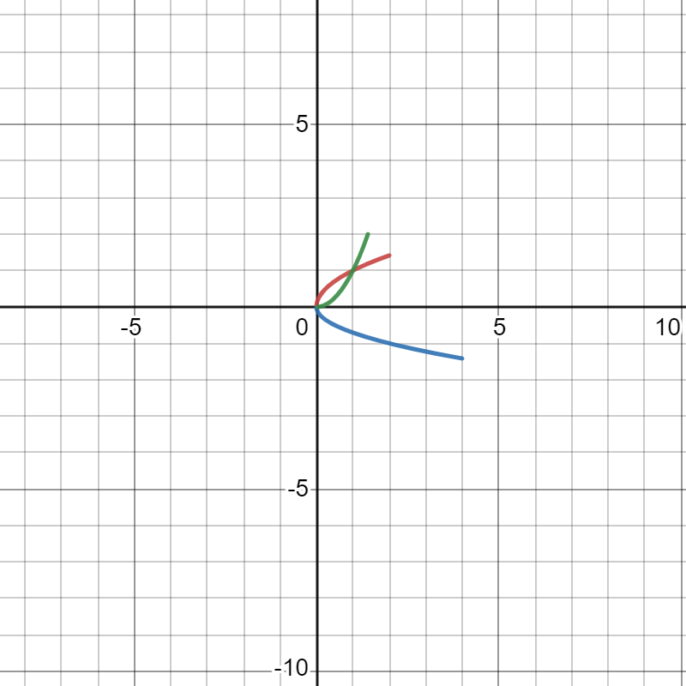
Having (a = -1) the graph image will be reflected 90 degrees on the opposite right side. Having (b = 0.5) the imaged will be stretched twice. Having (c = 0 and d = 0) the image will have the same starting point on both axis.
The green graph image is the transformation when x=f(y).it is the same stretched the same distance as the original image but it is generated on the opposite direction.

- F(X)=X^{1}/{3} {0<X<2}
Solution
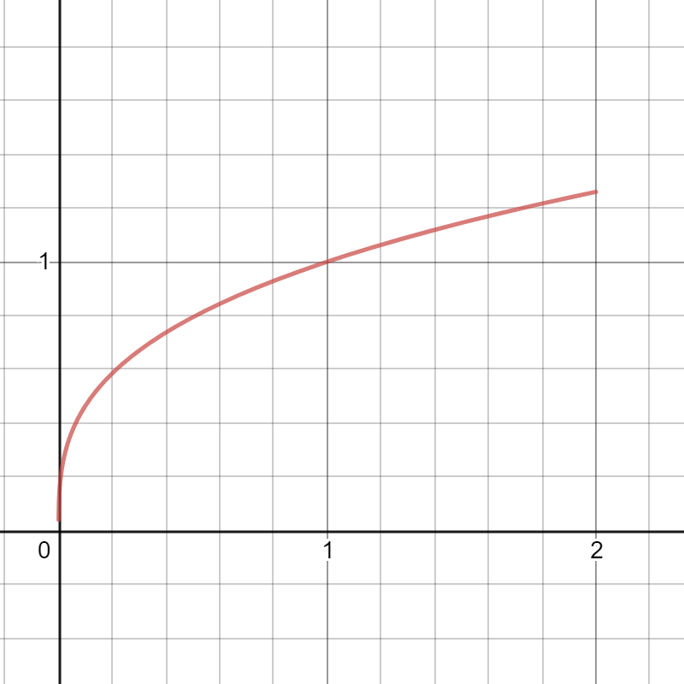
This is the original graph generated by the equation above.

Transformations
Having
y=af (b (x-c)) +d
a=-1
b=2
c=0
Domain of sqrt[3]{x}, ( 0 < x <2)
(0,2)
Range of sqrt[3]{x}, (0 <f(x)< sqrt[3]{2})
(0, sqrt[3]{2})
X - Axis interception points of sqrt[3]{x}, 0 < x <2 ; None
y - Axis interception points of sqrt[3]{x}, 0 < x <2 ; None

x=f(y)

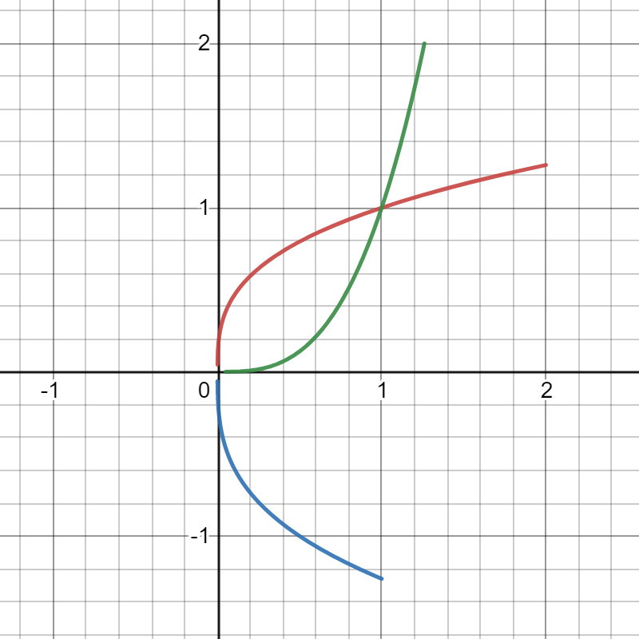

Having (a = -1) the graph image will be reflected 90 degrees on the opposite right side. Having (b =2) the imaged will have to shrink half of the original image. Having (c = 0 and d = 0) the image will have the same starting point on both axis.
The green graph image is the transformation when x=f(y).it is the same stretched the same distance as the original image but it is generated on the opposite direction.

- $f\left(x\right)=\frac{1}{x}$ {0<X<2}

Solution
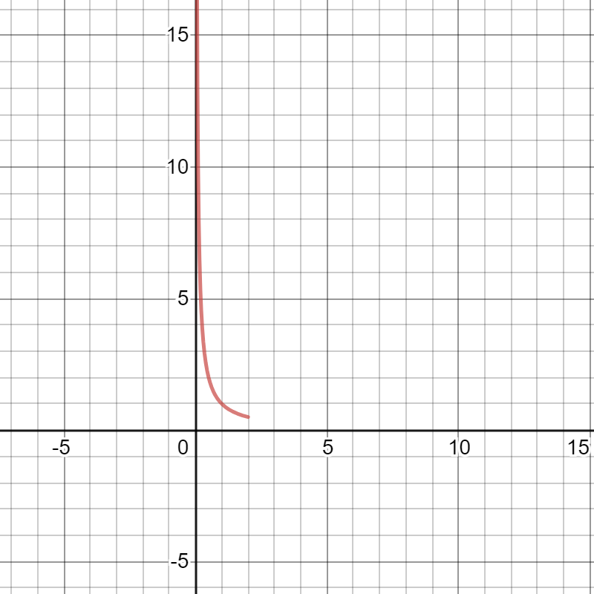
This is the original graph generated by the equation above.

Transformations
Having
Domain of 1/x, (0 < x <2)
(0, 2)
Range of 1/{x}, (0 <f(x) < 1/2)
(1/2, infinity)
X - Axis interception points 1/{x}, 0 < x <2 ; None
y - Axis interception points of 1/{x}, 0 < x <2 ; None

y=af (b (x-c)) +d
a=-1
b=1
c=0
d=0

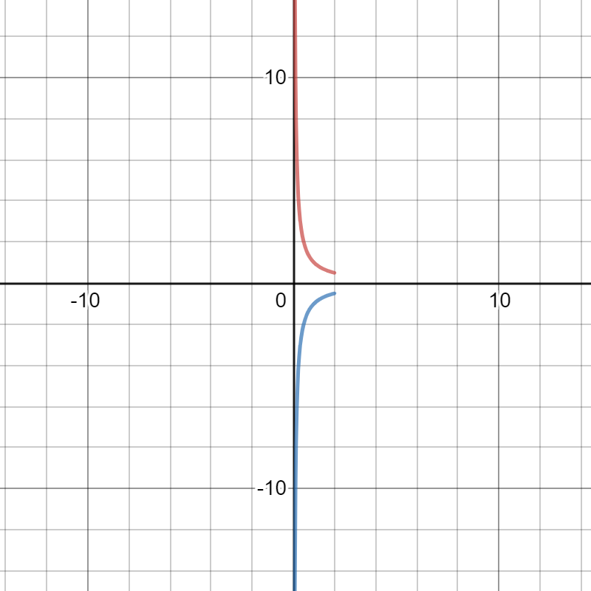
Having (a = -1) the graph image will be reflected 90 degrees on the opposite right side. Having (b =1) the imaged will have no shrinking or stretching. Having (c = 0 and d = 0) the image is reflected on the opposite side having different originally points.

Assuming
x=f(y)

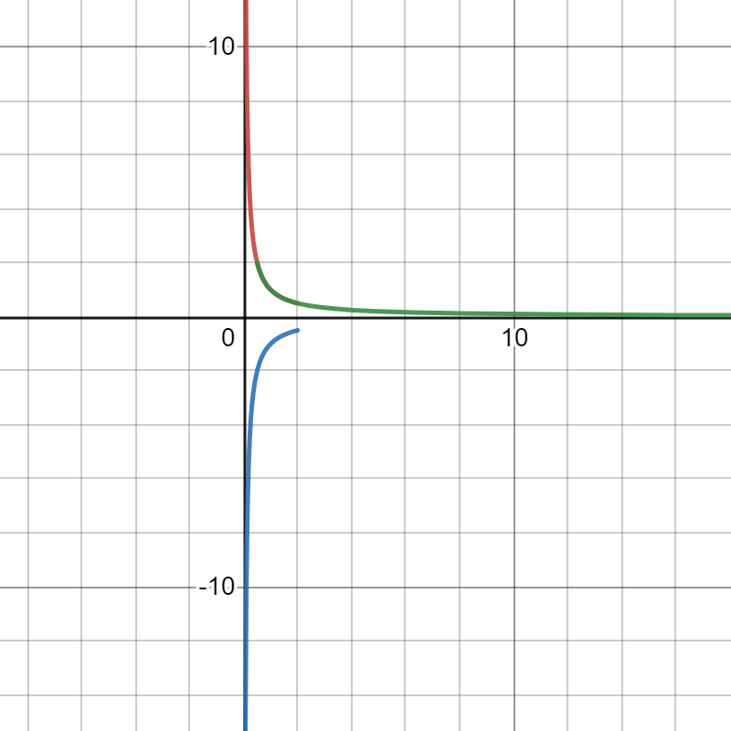
The graph image will be reflected 90 degrees on the right side. Having the same originally points as the original image.

G. f(x) =$\left|x\right|$ {0<x<2}
Solution
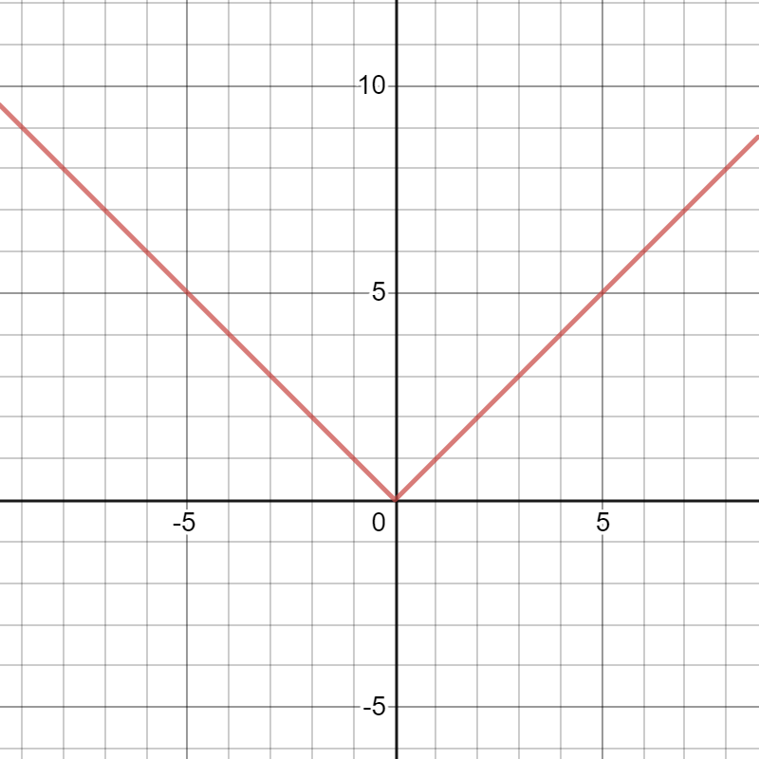
This is the original graph generated by the equation above.
Transformations
Having
F(x) =|x|
y=af (b (x-c)) +d
a=1
c=3.3
d=2.7
F(x) =3|x-c|+d
F(x) =af|x-2|+d
F(x) = - |x-c|+d
F(x) =af |x-c|+7
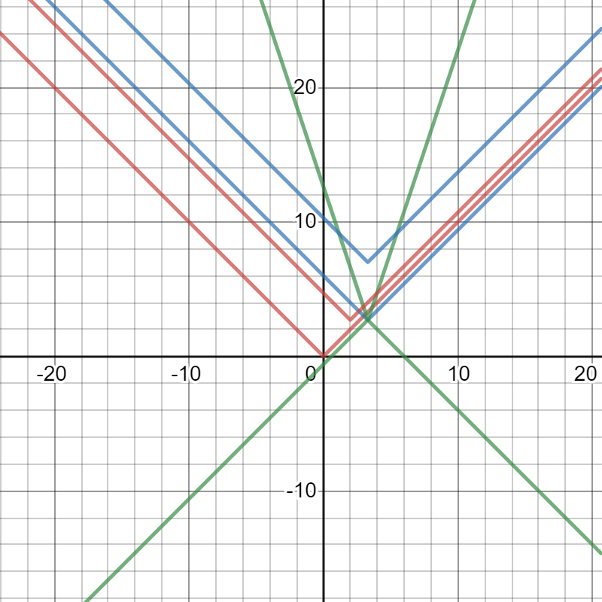

When AF is more than l1l, then there is a vertical stretch, if A is between 0 and 1, there is a vertical shrink. When A is negative, then the graph is reflected over y=d. When C is increased, the graph translates left, and decrease right. If d is increased, then the graph translates d units up, and d units down when it decreases.

h. $f\left(x\right)=⟦x⟧$ (greatest integer less than x) [floor(x)]
Solution

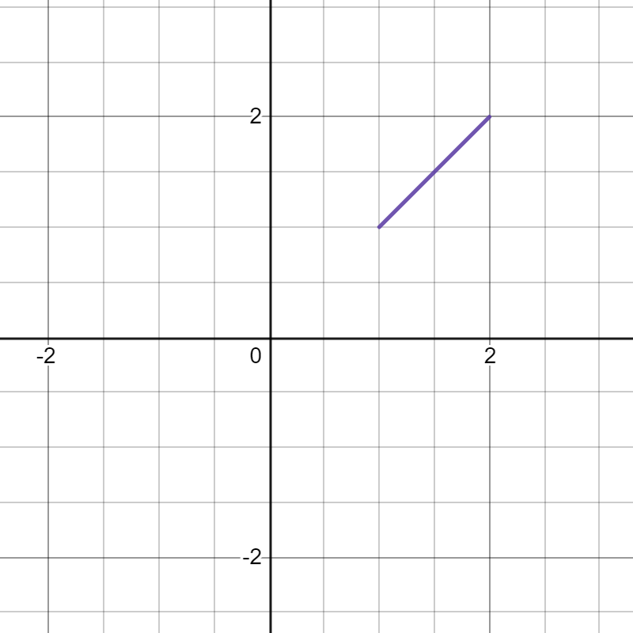
This is the original graph generated by the equation above.
Transformations
Having
y=af (b (x-c)) +d
a=-1
b=1
c=0
d=0
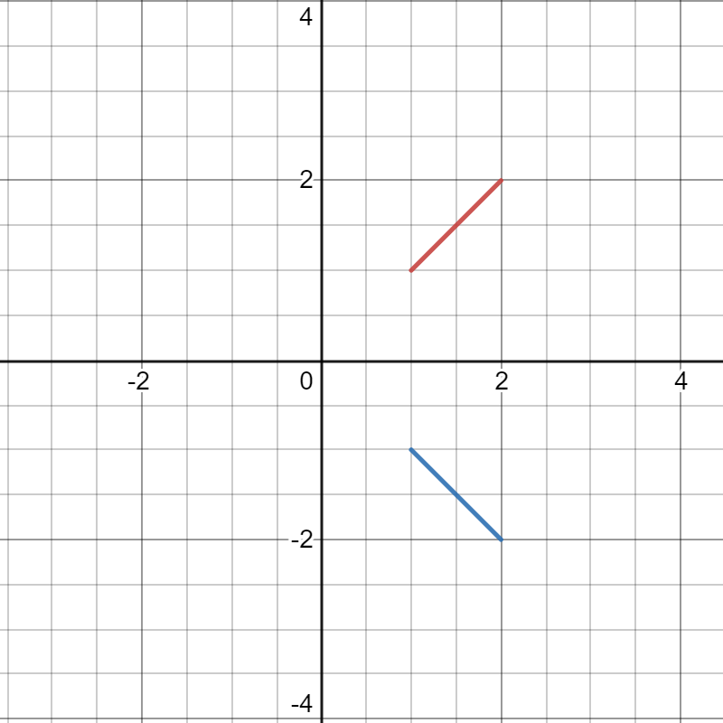
Having the (A = -1 and B = 1) the graph image is reflected on the opposite direction having the same but opposite co-ordinates. Having (c= 0 and d =0) the image starts the same point as the original one.

Letting
x=f(y)
We will have
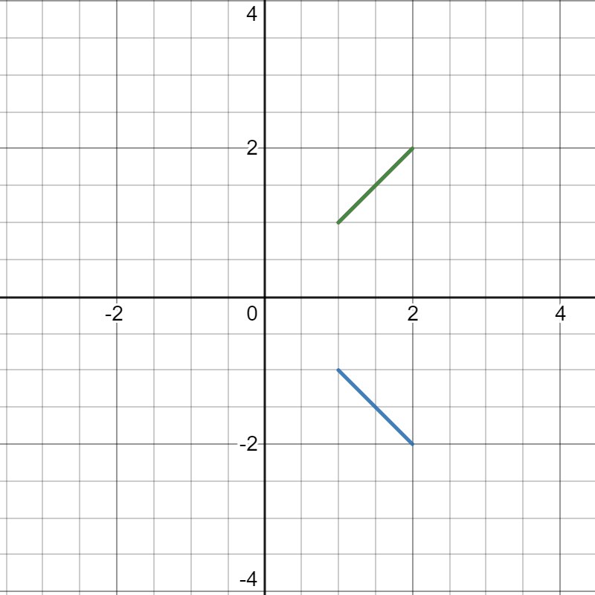
The graph image will be on the same position with the original one having the green color. Having no transformations

